**ABSTRACT**

The Report presents the work that has been carried out during the internship at “Zetacoding Innovative Solutions”, Bangalore. During my internship period I learnt Data Science. The Report contains different chapters which includes the information like company details, departments and projects carried out during the internship.

We have developed the system using Django for medicine application.

Due to the huge demand of online medicine delivery system there are very few companies that have recently started e-commerce based online medicine delivery services. A medicine delivery system is a solution designed specifically for users who want to order pharmacy products online and get them delivered to their home. A bit more details an online medicine delivery system is an online based web application that operates over the Internet and sends orders to customers. The main objective of the Django Project on Medical Shop Management System is to manage the details of Sells, Medicines etc. It manages all the information about Sells, Medical Shop, Inventory, Sells. The project is totally built at administrative end and thus only the administrator is guaranteed the access. The purpose of the project is to build an application program to reduce the manual work for managing the Sells, Medicines, Medical Shop, and Stocks.

Medical stores are established to provide medical supplies especially medicine supplies to the people. The medical store processes various activities daily such as conducting an inventory of medical supplies and medicine stocks, recording information of medicines and other medical supplies in the shop, recording purchases and sales reports, recording customer and suppliers’ information, and other medical store-related activities. Without digital transformation, medical store management is quite complicated and the shop’s staff will hurdle in providing efficient and adequate service to the client.

## CHAPTER 1

**ABOUT ZETACODING INNOVATIVE SOLUTIONS**

Zeta Coding Innovative Solutions is located in Bengaluru, Karnataka, India. We are service-based company for Software Development and Training. ZetaCoding has established itself as one of the leaders in providing quality software solutions and services across a wide-ranging technology to numerous software applications. Our professionals are well qualified, experienced and proficient to deliver the quality product on time. We provide end-to-end solutions to Project Management, Analysis, Development, Deployment and continuous support to the customer’s satisfactions. Our motto is to provide future technology training and Project development skills.

**MISSION**

To help our future engineers to understand the upfront research challenges of fast emerging technology age through advance techno-skilled education.

**VISION**

All our Engineers are endowed to E-Learning, Technology adaptive, self-growth & futuristic skills and making them prepared to the innovative world and generating leaders for tomorrow.

**VALUES**

**Our value follows our own Learning Technology Model (LEARN-IT)**

* Learning & Listening
* Excellence & Empowerment
* Adaptability & Accompany
* Respect & Responsibility
* Notion & Nestle
* Integrity & Inspiration
* Teamwork & Timings

**SERVICES**

* Software Training and Development
* IEEE Projects
* Ph. D Guidance & Assistance
* Internship Program
* Manpower Consultation & Placement

**WHY TO CHOOSE INTERNSHIP WITH US**

* Current Industry 5.0 technology
* Practical Lab Session Experience
* Problem Solving Skills
* Webinars from industry
* Assistance after Internship
* Student Project Demonstrations
* Added Advantage in Portfolio
* Presentation Skills

**BENEFITS OF INTERNSHIP SKILLS**

* Career management
* Phase management
* Employee guidance
* Project completion
* Communication skills
* Corporate skills
* Diplomacy & Teamwork
* Positive attitude

## CHAPTER 2

**ROAD MAP TO THE INTERNSHIP PROGRAM**

**TASK PERFORMED**

|  |
| --- |
| **Week 1 Activities** |
| * Introduction to the Internship Program * Selection of Internship Domain and Mini Project * Introduction to the Python Programming –Part 1 |

|  |
| --- |
| **Week 2 Activities** |
| * Python programming including OOPs –Part 2 * Introduction to Django Framework * Django Architecture - MVC |

|  |
| --- |
| **Week 3 Activities** |
| * Django form Handling Process * Template System and Deployment * Database Setup * HTML, CSS, JAVASCRIPT |

|  |
| --- |
| **Week 4 Activities** |
| * Implementation of Project – Tools : DJANGO Framework * Project Code Execution * Results and Conclusions * Report Preparation and Submission * Internship Presentation - PPT |

## CHAPTER 3

**ABOUT THE INTERNSHIP**

As per the regulations from various universities, we deliver the various levels of internship training and development. The internship duration may be from 4 -8 weeks. We provide solutions to the students that they can upgrade their knowledge and apply, convert it into project development. We have proposed our internship program keeping in focus of present demand of industry standards, so that we can make ready our students to fill the gap between industry-academics and value added courses to enhance the skills which helps them to build the strong career in the field of computer science.

An internship during college studies can help to enhance quality of higher education and to improve skills & competencies amongst students. It helps to fill the gap between the theoretical learning at class room and practical application at work place. It is also seen that the student undergoing internships while their 3 years degree course are not able to perform better in their regular exams because of time constraints. On the other hand, Internships also help them to achieve higher professional competencies and excellence in their field of interest and so that they can perform better in their future job with full potential knowledge

**3.1 Benefit of Internship**

Finding work can be a real challenge, especially if you don't have any experience. Yet to get experience you must first find a job. It is a nasty catch that can be difficult to get around but an internship is a good way to do it. Internships provide work experience opportunities to university students like me, recent graduates and people considering career changes.

Universities encourage students like me to participate in internship programs because they believe that there are many benefits that student’s get in a supervised real life work environment in which they have the opportunity to put theory into practice. However, most of the studies on internship programs have concentrated on the evaluation of the benefits by looking at academic performance of students after attachment These studies have shown that subsequent academic performance of students who return from internship programs tend to be better than those who did not go for internship. However, have found little evidence that internship programs help students to perform better in class. Apart from possible improvement in academic performance, another benefit that students get is a chance to acquire some generic employability skills, which help them to easily transition from the learning institution to employment. These employability skills include teamwork, relationship building, leadership, human relations, presentation, communication, time management, initiative, enterprise and abilities to problem solve and persuade. The students also improve in their use of technologies, ability to take criticism, and to see the bigger challenges.

When job opportunities are hard to come by, students increasingly relied on internships to differentiate themselves from their non-participating counterparts. It seems employers are willing to give employment to a job seeker who has a working experience even if it is in the form of internship attachment. The link between internship participation and securing of a job sometimes tends to be taken for granted. Students expected to be provided with full-time employment at the completion of the internship. Many students enroll into degree programs without having a clear understanding of the profession they are getting into. Participation in internship programs gives students a chance to know the profession and a possibility of making a final decision on whether they are in the right career path or not.

## 3.2 Gain Valuable Work Experience

An internship provides the opportunity to gain hands on work experience that you just cannot get in the classroom. First time job seekers and career changers are not usually desirable candidates, but companies are willing to train them as interns and give them the experience they would need to get a job.

## Networking Opportunities

Internships are a great way to meet people in your field. Even if you have experience, knowing people never hurts. An internship allows you to meet people who might help you land a job later on and give you the contacts in the industry you are trying to break into. In addition, references from people in the Research field will really add weight to your application.

* **Apply Classroom Knowledge**

An internship can be seen as the pinnacle of your undergraduate education and give you the chance to use the skills you have learned in the classroom in a real-world setting. It is a chance to prove the worth of your qualifications and to show that you can perform in the role you has been given.

## Gain Confidence

Getting experience is a great way to build your confidence. What's more, if you have an impressive resume, you will be more confident in your chances of securing a job. After you have done an internship, if an interviewer asks if you know how to do something, you will not say “um, yes, I think I would be able to do that" but can say “absolutely" and supplement your assertion with examples.

**3.3 Non-Technical Outcomes**

**A. Personality Development**

Personality development is defined as the relatively enduring patterns of thoughts, feelings, and behaviors that distinguish individuals from one another. The personality is the typical pattern of thinking, feeling, and behaviors that make a person unique. When we say that someone has a "good personality" we mean that they are likeable, interesting and pleasant to be with. The dominant view in the field of personality psychology today holds that personality emerges early and continues to change in meaningful ways throughout the lifespan.

Everyone wants to be attractive to others. To that end, having a good personality is vital - probably even more so than good looks. In fact, approximately 85 percent of your success and happiness will be a result of how well you interact with others. Ultimately, your personality determines whether people are attracted to, or shy away from you.

While good grooming and looks is part of it, the scope of personality development is quite broad. It includes knowing how to dress well, social graces, grooming, speech and interpersonal skills.

* It gives you more confidence.
* It makes you look more credible. Despite the saying that you do not judge a book by its cover, people do tend to judge people by their clothing and how it is worn. This does not mean buying expensive clothes. We all know people who look shabby in expensive clothes. There are also people who look great even if their attire is inexpensive.
* It encourages people to interact with you. Studies have consistently shown that people communicate more openly with people they are comfortable with. If your hygiene and social graces.
* It enhances your capacity to lead and motivate. A person with a winning personality will be able to motivate better.

**3.3.1 Verbal communication**: also known as speaking, is an important form of communication in a healthcare facility. Planning and organizing your thoughts is a critical part of verbal communication. This involves thinking about who will receive the message and what you want to convey Making notes before a phone call, having an agenda for a meeting, or researching information you wish to give to someone in advance are all methods you can use to ensure clear communication.

According to motivational speaker and entrepreneur Mr. Pat Croce, effective communication involves much more than choosing the right words. Mr. Croce recommends five rules to incorporate while conveying a message, known as the 5C’s of Communication.

**3.3.2 Clear:** Speak in black-and-white terms to clearly state your message. Allow questions from the recipient of your communication to ensure you are understood.

**3.3.3 Concise.** Do not ramble. Your important message can be lost in then on essential information you include—get to the point.

1**. Consistent.** Make the message consistent at all times. If you are telling your supervisor about an incident that you have observed, do not change your story to make it more dramatic. Report your findings in a consistent, accurate manner. Do not tell one person what you saw and later change your observations as you re tell the story to another person.

1. **Credible.** People can tell if your words are insincere make sure your message is real. Do not heap praise on someone just because you want to win their favor. It is important that you mean what you say.
2. **Courteous.** Words and phrases such as “hello,” “thank you,” “please,” excuse me,” and “I’m sorry” are easy, effective ways to demonstrate respect. Being courteous when you communicate sets the right tone and attitude. Courtesy is mandatory in the workplace, even if you are interacting with someone you dislike. Keep your personal feelings out of your work interactions. Having an open mind during verbal communication is also very important. Making assumptions about what someone is going to say before he or she speaks might cause you to miss the essence of the message.
   * If you have had disagreements with the speaker, you might negatively translate a message into your assumption about what you are hearing. Keeping an open mind and listening respectfully without emotion is critical to open, clear communication. Personal problems should not be brought into the workplace. Some people have a tendency to be sarcastic, or use words that mean the opposite of what you feel, to express frustration or in an attempt to be funny.

**3.3.4 Public speaking**

You may be called upon to give a presentation in class or in your role as about the work done. Whether you are giving a short talk to fellow classmates or explaining a procedure to fellow workers, there are several public speaking strategies to keep in mind.

* + Be prepared. Practice your presentation several times. Know more about your material than you include in your speech. Use humor, personal stories, and conversation al language if relevant.
  + Look at the audience and establish direct eye contact. Smile, develop rapport, and notice if your audience looks like they are following what you are saying or if they look puzzled or confused.
  + Relax and slowly count to three before beginning to allow yourself time to calm down. Don’t apologize for being nervous. Realize that people want you to succeed.
  + Know your room. Arrive early to the venue and walk around the speaking area. Practice using the microphone if possible, and make sure any visual aids you may have are present and in working order.
  + Remember to be concise and avoid a long, repetitive presentation. Be aware of signs of lagging attention in your audience.
  + Develop visuals if appropriate. You may use project visuals, handouts, PowerPoint® presentations, or demonstrations. Visuals can effectively reinforce your speech. Make sure any technology you might need to use for your visuals is working before the presentation begins.
  + Be well acquainted with your topic. Reading continually from note cards loses your audience’s attention. Write down key phrases, quotes, and stories in large letters on note cards to jog your memory as you are talking. Show enthusiasm for your topic.
  + Practice, practice, practice! Speak slowly and calmly, but louder than your usual speaking voice (unless you are using a microphone).

**B. Time Management**

a. “Time management” refers to the way that you organize and plan how long you spend on specific activities. It may seem counter-intuitive to dedicate precious time to learning about time management, instead of using it to get on with your work, but the benefits are enormous:

b. During internship Communication Challenges Anything that interferes with communication can lead to a misinterpretation of your message. However, various factors can interfere specifically with your ability to communicate verbally with your patients.

c. Patients such as the hearing impaired, some intellectually disabled individuals, or a patient who does not speak your language pose challenges for verbal communication, possibly requiring the use of a translator.

d. Speaking may be difficult for a patient who has suffered a stroke or stutters badly. In addition to these considerations, communication must be geared toward a patient’s ability to understand.

e. This often means substituting basic terms for challenging medical terms that could confuse some people.

f. Even if a coworker is translating for you, you can’t assume that a fellow employee unfamiliar with your specific field will understand your use of technical terms. You may want to simplify your language for both the translator and the patient.

**3.4 About Python Programming**

Python is a widely used high-level programming language for general-purpose programming, created by Guido van Rossum and first released in 1991.It is a high-level, interpreted, interactive and object-oriented scripting language. Python is designed to be highly readable. It uses English keywords frequently whereas the other languages use punctuations.

* Python is interpreted: Python is processed at runtime by the interpreter. You do not need to compile your program before executing it, like we do in C, C++, java and other programming language.
* Python is Interactive: You can actually sit at a Python prompt and interact with the interpreter directly to write your programs.
* Python is Object-Oriented: Python supports Object-Oriented style or technique of programming that encapsulates code within objects.
* Python is a Beginner's Language: Python is a great language for the beginner level programmers and supports the development of a wide range of applications.

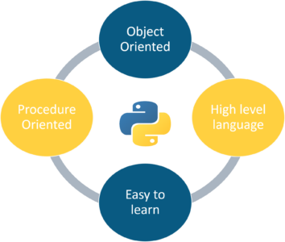

Figure 3.1: Python Structure

## 3.5 Python Features

* **Easy-to-learn**: Python has few keywords, simple structure, and a clearly defined syntax. This allows a student to pick up the language quickly.
* **Easy-to-read**: Python code is more clearly defined and visible to the eyes.
* **Easy-to-maintain**: Python's source code is fairly easy-to-maintain.
* **A broad standard library**: Python's bulk of the library is very portable and cross platform compatible on UNIX, Windows, and Macintosh.
* **Interactive Mode**: Python has support for an interactive mode, which allows interactive testing and debugging of snippets of code.
* **Portable**: Python can run on a wide variety of hardware platforms and has the same interface on all platforms.
* **Extendable**: You can add low-level modules to the Python interpreter. These modules enable programmers to add to or customize their tools to be more efficient.
* **Databases**: Python provides interfaces to all major commercial databases.
* **GUI Programming**: Python supports GUI applications that can be created and ported to many system calls, libraries and windows systems, such as Windows MFC, Macintosh, and the X Window system of UNIX.
* **Scalable**: Python provides a better structure and support for large programs than shell scripting.

Apart from the above-mentioned features, Python has a big list of good features. A few are listed below

* It supports functional and structured programming methods as well as OOP.
* It can be used as a scripting language or can be compiled to byte-code for building large applications.
* It provides very high-level dynamic data types and supports dynamic type checking.
* It supports automatic garbage collection.
* It can be easily integrated with C, C++, COM, ActiveX, COBRA, and Java.

**3.6 What is Django?**

* The Django web framework is a free, open source framework that can speed up development of a web application being built in the Python programming language.
* Django—pronounced “Jango,” named after the famous jazz guitarist Django Reinhardt—is a free, open source framework that was first publicly released in 2005. Django facilitates “rapid development and clean, pragmatic design.” The Django web framework, deployed on a web server, can help developers quickly produce a web frontend that’s feature-rich, secure and scalable.
* this framework uses a famous tag line:**The web framework for perfectionists with deadlines.**
* By using Django, we can build web applications in very less time. Django is designed in such a manner that it handles much of configure things automatically, so we can focus on application development only.

**3.7 Benefits**

* Make database management more Python-like
* Starting a Django project allows you to build your application’s entire data model in Python without needing to use SQL. Using an object-relational mapper (ORM), Django converts traditional database structure into Python classes to make it easier to work within a fully Python environment. Django-MySQL supports the JSON data type and related functions.
* In Django, your database tables become Python classes. Web applications access and manage data through Django models. The fields of the database are simply converted into class attributes. If you’re familiar with class attribute definition in Python, you can easily design and manage a Django database.
* Django Web Framework offers a shortcut to full integration with your application’s database. It provides CRUD (create, read, update, delete) functionality, HttpResponse and cross-site scripting, supplies user management capabilities, offers software administration features and more. You import the packages, connect to your database and then get back to work developing the parts of your application that make your product unique.
* Create dynamic pages with templates
* Because Django is designed to be used for web app development, it needs a way to easily create dynamic HTML that displays your user’s unique data. The Django application produces that dynamic HTML with a built-in templating engine called the Django template language (DTL).
* An HTML template allows Django developers to combine static elements (including design elements such as colors, logos, or text) with data (such as user names or locations) to create a new web page on the fly. With model-view-controller (MVC), if you want your application to greet a user by name when they log in, you can build a template that displays the static text (“Welcome to the site, X”) then use a dynamic placeholder to automatically display the user’s first name from your database. When the page renders, it will combine the dynamic elements with the static ones to create a seamless user experience.
* Enhance security
* When answering, "What is Django", we must talk about what special features Django offers for security. Web apps are frequent targets of hackers, especially applications that store user login information or financial data. Django offers features to help protect your application and your users.
* One of the biggest risks for sites that accept user-entered data is that a malicious user will inject code with their data that can have a disastrous effect on your system. To protect against attacks like these, Django templates automatically escape common HTML characters in any user-entered field. For example, it will automatically convert ‘<’ to ‘&lt;’ to make it difficult to inject malicious code into your program. Django protects from SQL injection in a similar way, reinterpreting unauthorized commands so that users can’t sneak their own code into your database.
* Web developers can also count on Django APIs to automatically use cross-site request forgery (CSRF) protection to insert user-specific secret tokens into POST requests. As a result, web developers can prevent malicious users from duplicating other POST requests to masquerade as authorized users.
* The protection of Django goes beyond its explicit security features: security efforts are enhanced by the extensive experience and expertise of the Django user base. If you build your entire web app from scratch, you run the risk of accidentally introducing a security vulnerability into your module. Django packages are widely used, open source and well-reviewed by web developers, so you can be more confident that they’ll protect your data.
  1. **What is HTML?**

**HTML Stands for Hypertext Markup Language, where** Hypertext stands for Link between web pages. Markup Language means Text between tags that define the structure.

HTML is a markup language that is used to create web pages. It defines how the web page looks and how to display content with the help of elements. It forms or defines the structure of our Web Page, thus it forms or defines the structure of our Web Page. We must remember to save your file with .html extension. In this HTML Tutorial, we’ll understand all the basic concepts required to kick-start your journey in HTML.

**3.8.1 Applications of HTML**

**HTML is used for various purposes. Let us take a look at them**

**Web Pages development:**HTML is famously used for creating web pages on the world wide web. Every web page contains a set of HTML tags and hyperlinks which are used to connect other pages. Every page on the internet is written using HTML.

**Navigating the Internet**:Navigating on the internet would have been quite a tedious task without HTML. The anchor tags of HTML allows us to link pages and navigate easily. Imagine our life without anchor tags, you would literally have to enter URL everytime. Using achor tags, you can also navigate within a webpage.

**Embedding Images and Videos**:HTML allows us to embed images and videos with ease and gives us features to adjust height, position and even rendering type. You can adjust controls, thumbnails, timestamps and much more for videos. Earlier this was done using Flash and HTML has made it easier with the help of **<video>** tag.

**Clinet-side storage**:HTML5 has made client-side storage possible using localStorage and IndexD due to which we no longer need to reply on Cookies. Both of these tactics have their own set of rules and characteristics. String-based hash-table storage is provided by localStorage. Its API is straightforward, with setItem, getItem, and removeItem functions available to developers. On the other hand, IndexDB is a larger and more capable client-side data store. With the user’s permission, the IndexDB database can be enlarged.

1. **Game Development:**Although you cannot create complex high-end video games with HTML, the **<canvas>** element of HTML can be used to make 2D and 3D games using CSS and JavaScript which can be run on browsers.
2. **Data Entry Support:**With the usage of new HTML5 standards in all the latest browsers, developers can simply add the tags for required fields, text, data format, etc. and get the data. HTML5 now has several new attributes for data-entry and validation purposes.
3. **Interacting with Native APIs:**With the help of HTML, you can interact with your Operating system. With this feature, you can easily drag files onto a web page to upload, full-screen a video, and much more.

**3.9 CSS**

CSS is a stylesheet language that describes the presentation of an HTML (or XML) document. CSS describes how elements must be rendered on screen, on paper, or in other media. This tutorial will teach you CSS from basic to advanced.

**3.9.1 What is CSS?**

• CSS stands for Cascading Style Sheets

• CSS describes how HTML elements are to be displayed on screen, paper, or in other media

• CSS saves a lot of work. It can control the layout of multiple web pages all at once

• External stylesheets are stored in CSS files

**3.9.2 Why Use CSS?**

CSS is used to define styles for your web pages, including the design, layout and variations in display for different devices and screen sizes.

Three Ways to Insert CSS Styling can be added to HTML elements in 3 ways:

• Inline - using a style attribute in HTML elements

• Internal - using a section

• External - using one or more external CSS files The most common way to add styling, is to keep the styles in separate CSS files.

1.Inline CSS

Inline CSS is used to style a specific HTML element. For this CSS style, you’ll only need to add the **style** attribute to each HTML tag, without using selectors.

This CSS type is not really recommended, as each HTML tag needs to be styled individually. Managing your website may become too hard if you only use inline CSS.

However, inline CSS in HTML can be useful in some situations. For example, in cases where you don’t have access to CSS files or need to apply styles for a single element only.

**3.9.3 Advantages of Inline CSS:**

You can easily and quickly insert CSS rules to an HTML page. That’s why this method is useful for testing or previewing the changes, and performing quick-fixes to your website.

You don’t need to create and upload a separate document as in the external style.

**3.9.4 Disadvantages of Inline CSS:**

Adding CSS rules to every HTML element is time-consuming and makes your HTML structure messy.

Styling multiple elements can affect your page’s size and download time.

**2.Internal CSS**

Internal or embedded CSS requires you to add **<style>** tag in the **<head>** section of your HTML document.

This CSS style is an effective method of styling a single page. However, using this style for multiple pages is time-consuming as you need to put CSS rules on every page of your website.

**Advantages of Internal CSS:**

You can use class and **ID selectors** in this style sheet.

Since you’ll only add the code within the same HTML file, you don’t need to upload multiple files.

**Disadvantages of Internal CSS:**

Adding the code to the HTML document can increase the page’s size and loading time.

**3.External CSS**

With external CSS, you’ll link your web pages to an external **.css** file, which can be created by any text editor in your device (e.g., **Notepad++**).

This CSS type is a more efficient method, especially for styling a large website. By editing one **.css** file, you can change your entire site at once.

Follow these steps to use external CSS:

Create a new **.css** file with the text editor, and add the style rules.

In the **<head>** section of your HTML sheet, add a reference to your external **.css** file right after **<title>** tag

**Advantages of External CSS:**

Since the CSS code is in a separate document, your HTML files will have a cleaner structure and are smaller in size.

You can use the same **.css** file for multiple pages.

**Disadvantages of External CSS:**

Your pages may not be rendered correctly until the external CSS is loaded.

Uploading or linking to multiple CSS files can increase your site’s download time.

**3.10 An Introduction of JavaScript**

**JavaScript** is a lightweight, interpreted **programming** language. It is designed for creating network-centric applications. It is complimentary to and integrated with Java. **JavaScript** is very easy to implement because it is integrated with HTML. It is open and cross-platform.

## Why to Learn Javascript

**Javascript** is a MUST for students and working professionals to become a great Software Engineer specially when they are working in Web Development Domain. I will list down some of the key advantages of learning Javascript:

* Javascript is the most popular **programming language** in the world and that makes it a programmer’s great choice. Once you learnt Javascript, it helps you developing great front-end as well as back-end softwares using different Javascript based frameworks like jQuery, Node.JS etc.
* Javascript is everywhere, it comes installed on every modern web browser and so to learn Javascript you really do not need any special environment setup. For example Chrome, Mozilla Firefox , Safari and every browser you know as of today, supports Javascript.
* Javascript helps you create really beautiful and crazy fast websites. You can develop your website with a console like look and feel and give your users the best Graphical User Experience.
* JavaScript usage has now extended to mobile app development, desktop app development, and game development. This opens many opportunities for you as Javascript Programmer.
* Due to high demand, there is tons of job growth and high pay for those who know JavaScript. You can navigate over to different job sites to see what having JavaScript skills looks like in the job market.
* Great thing about Javascript is that you will find tons of frameworks and Libraries already developed which can be used directly in your software development to reduce your time to market.

**CHAPTER 4**

**SYSTEM REQUIREMENTS AND SPECIFICATIONS**

The System Requirements Specification document describes all data, functional and behavioral requirements of the software under production or development. A functional requirement document defines the functionality of a system or one of its subsystems. It also depends upon the type of software, expected users and the type of system where the software is used. Non-functional requirement is a requirement that specifies criteria that can be used to judge the operation of a system, rather than specific behaviors.

**4.1 Software Requirements**

Scripting language : Python Programming

Operating System : Microsoft Windows 8/10/11

Frontend Tools : HTML, CSS,JAVASCRIPT

Framework : Django

Packages : Django==2.2.7, django-tinymce4-lite==1.7.5

**4.2 Hardware Requirements**

Processor : 3.0 GHz and Above

Output Devices : Monitor (LCD)

Input Devices : Keyboard

Hard Disk : 1 TB

RAM : 8GB or Above

**CHAPTER 5**

**SYSTEM DESIGN**

System Design is a process of planning a new business system or replacing an existing system by defining its components or modules to satisfy the specific requirements. Before planning, you need to understand the old system thoroughly and determine how computers can best be used in order to operate efficiently. System analysis is conducted for the purpose of studying a system or its parts in order to identify its objectives. It is a problem-solving technique that improves the system and ensures that all the components of the system work efficiently to accomplish their purpose.

**5.1 SYSTEM DESIGN**

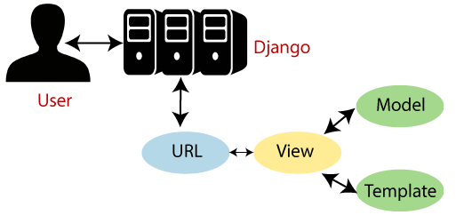

Figure 5.1: MVT Architecture of Django

**1. Model**

The Model is the part of the web-app which acts as a mediator between the website interface and the database. In technical terms, it is the object which implements the logic for the application’s data domain. There are times when the application may only take data in a particular dataset, and directly send it to the view (UI component) without needing any database then the dataset is considered as a model.

Although today if we want any kind of website we need to have some sort of database as we must be requiring some user input even if we are creating a simple blog site.

The Model is the component which contains Business Logic in Django architecture.

### **2. View**

This component contains the UI logic in the Django architecture. View is actually the User Interface of the web-application and contains the parts like HTML, CSS and other frontend technologies. Generally, this UI creates from the Models component, i.e., the content comes from the Models component.

**For example:**

When you click on any link or interact with the website components, the new webpages that website generates is actually the specific views that stores and generates when we are interacting with the specific components.

### **3. Controller**

The controller as the name suggests is the main control component. What that means is, the controller handles the user interaction and selects a view according to the model. The main task of the controller is to select a view component according to the user interaction and also applying the model component. This architecture has lots of advantages and that’s why Django is also based on this architecture. It takes the same model to an advanced level.

**For example:**

When we combine the two previous examples, then we can very clearly see that the component which is actually selecting different views and transferring the data to the model’s component is the controller.

**CHAPTER 6**

**SYSTEM IMPLEMENTATION**

The Food Order System is an E-commerce web application developed using Django Framework. It contains features such as login/signup, view all food items, add food items to card and finally checkout using payment systems. The system runs Django Framework in back-end and HTML, CSS in front-end. It contains similar functionalities and it has interactive UI design using which users can order foods online and track their cart and their orders. Similarly, it also contains an admin panel through which all the users, orders and carts can be managed by the administrator.

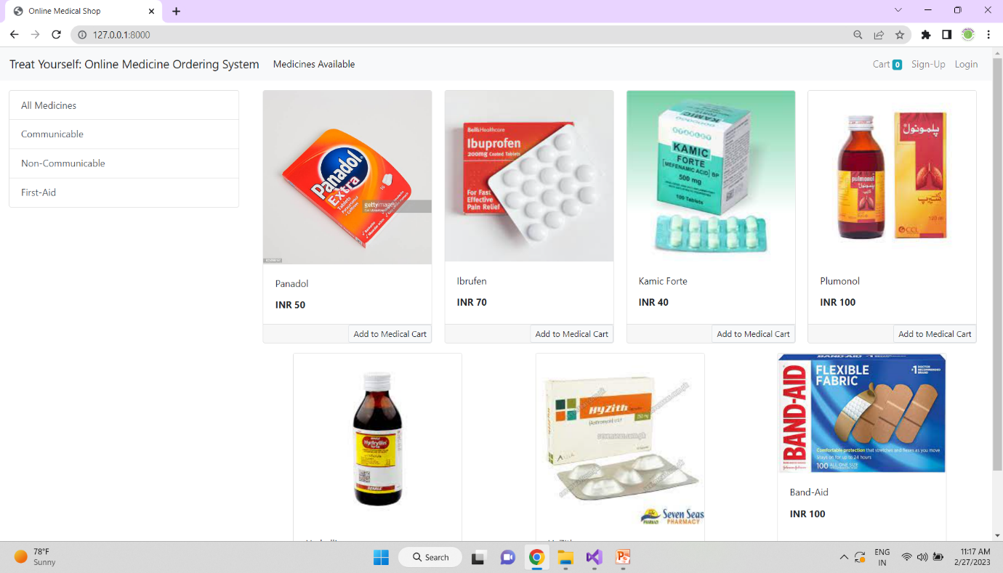

Figure 6.1: Menu Page of Administrative Panel

This project is an online medicine ordering System. This project’s main goal is to give the Pharmacy’s Customers an automated and online platform to order their medicine. The system can help both customers and the management.

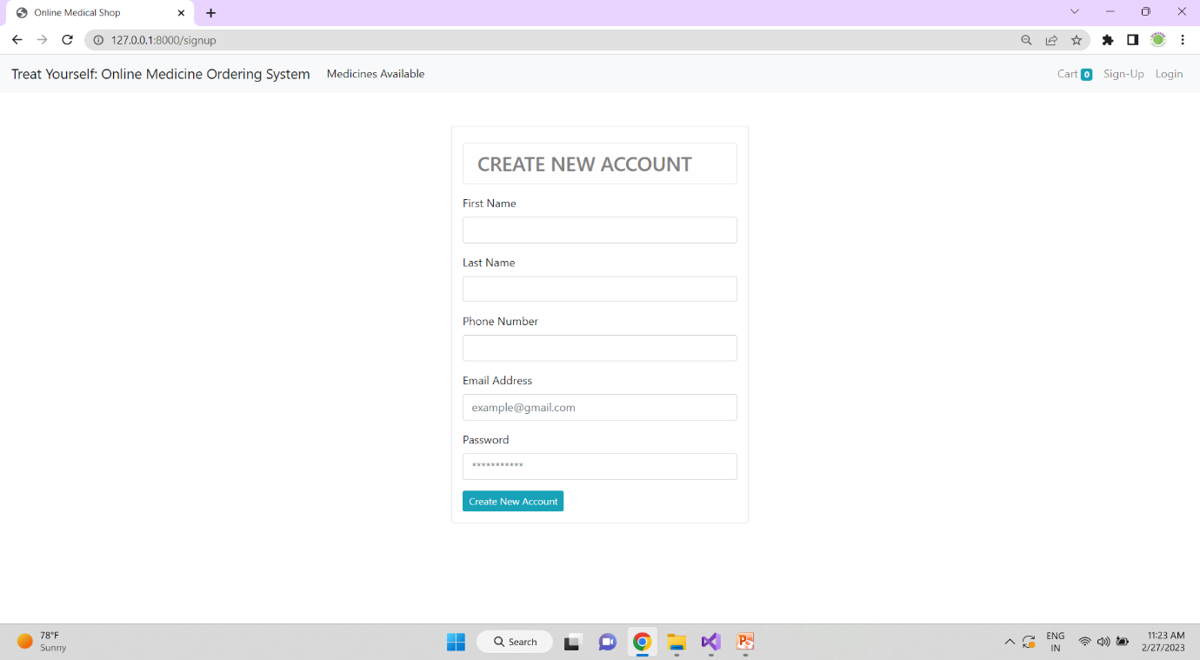

Figure 6.2: Creating the User Account

First you have to create an account. Once the account is established, you will be able to purchase specialty products and bill them to your Pharmaceutical Distribution account.

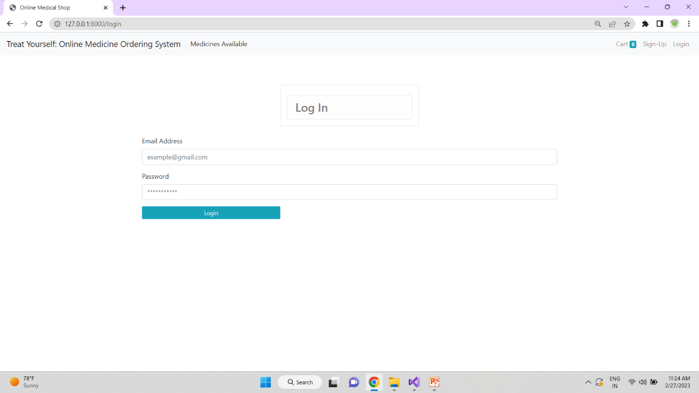

Figure 6.3: Enter Credentials to login

Once you create the account. Login page successfully allowed you by taking the email address as well as password.

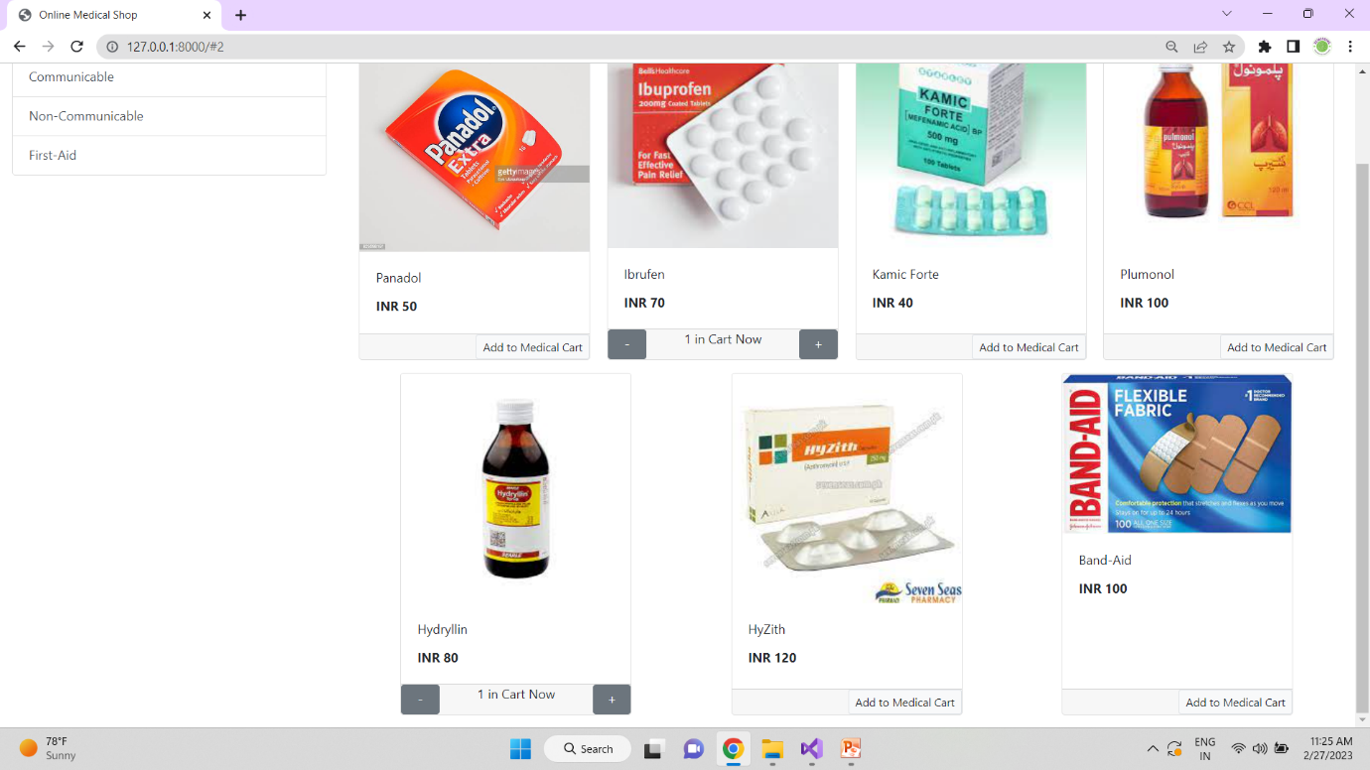

Figure 6.4: Medicine Details Communicable, Non-Communicable and First-Aid

The user can search and select medicines by their name. The system will allow customer to register themselves.

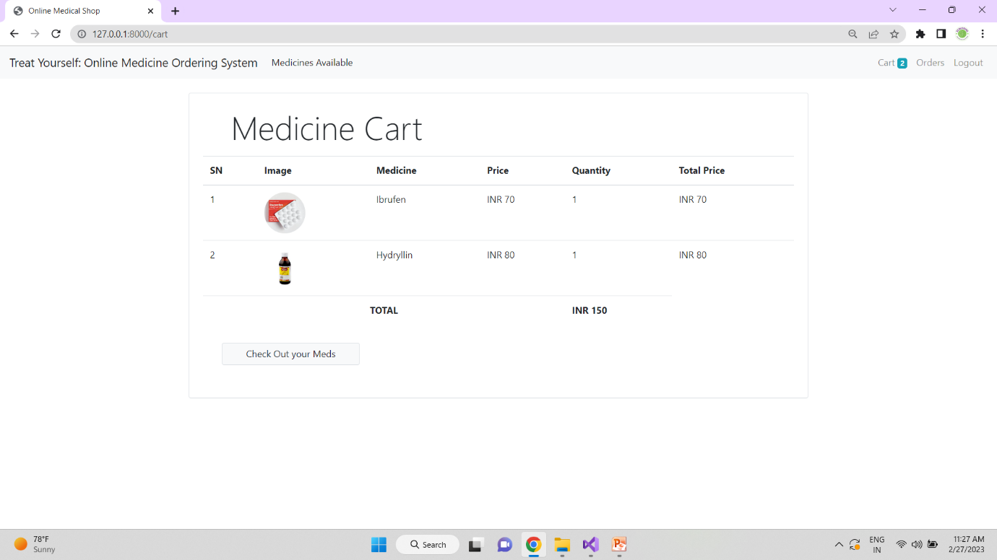

Figure 6.5: Medicine cart Information

The medicine Cart shows the information about the Medicine , Price, Quantity and the final price.

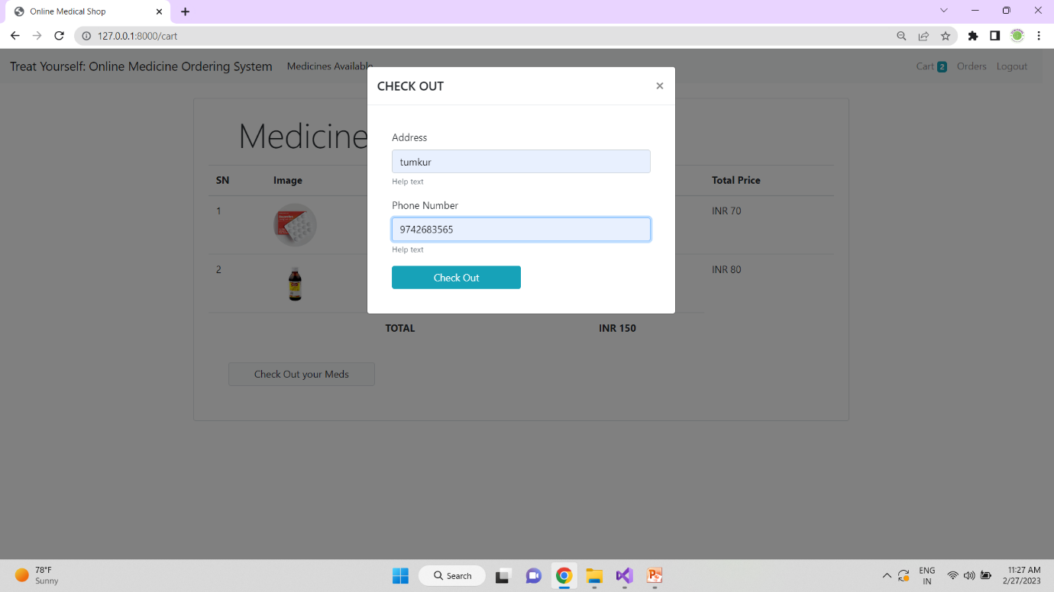

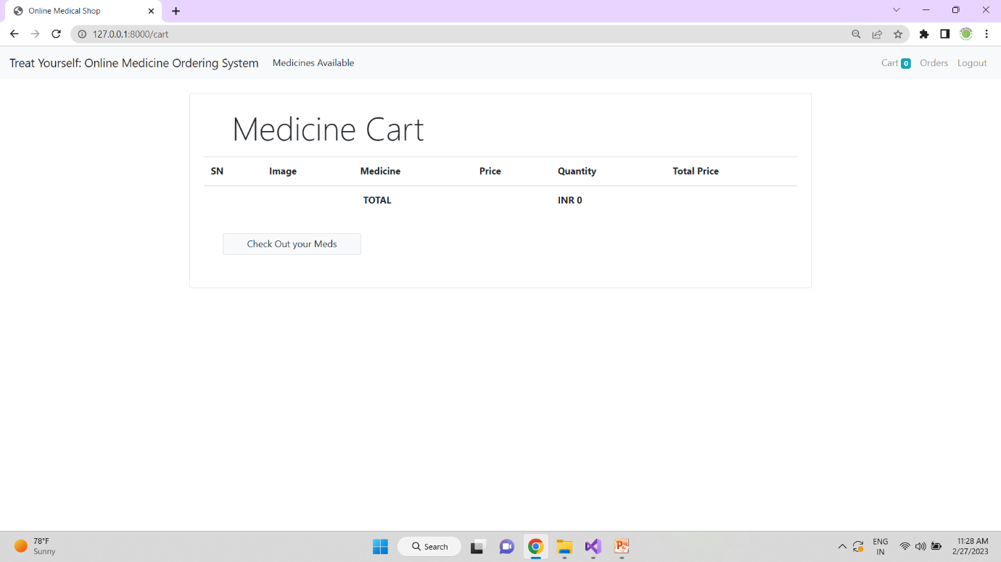

Figure 6.6: Checkout Details

For ease of access Healthcare Facilities use medicine carts to transport, organize, and store medical equipment to the patients beside.

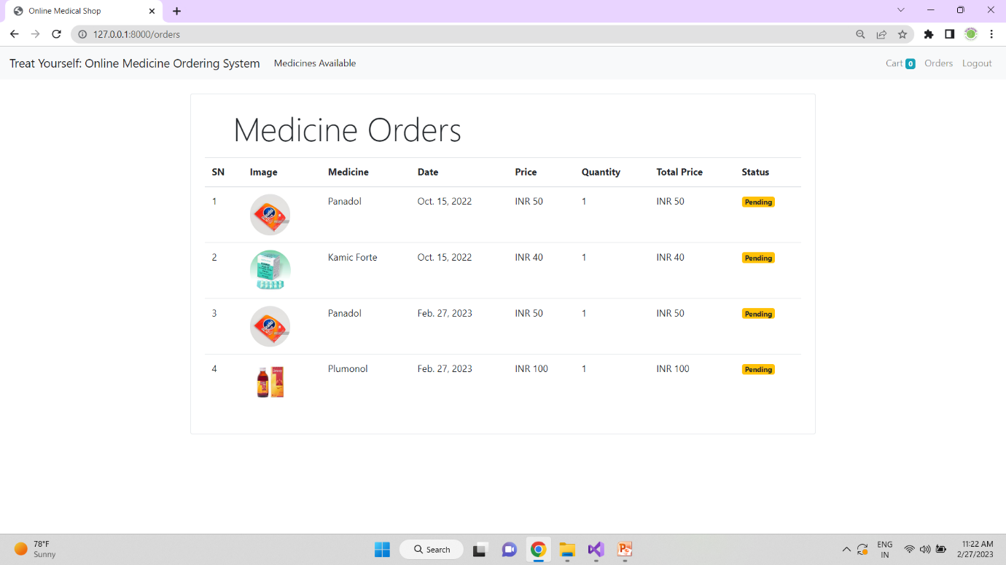

Figure 6.7: Medicine Orders

A medicine order is written by a practitioner for a medication that will be administered medications orders are required before a nurse may administer medications. A medicine order must include medicine image, medicine date, price, quantity, total price and status.

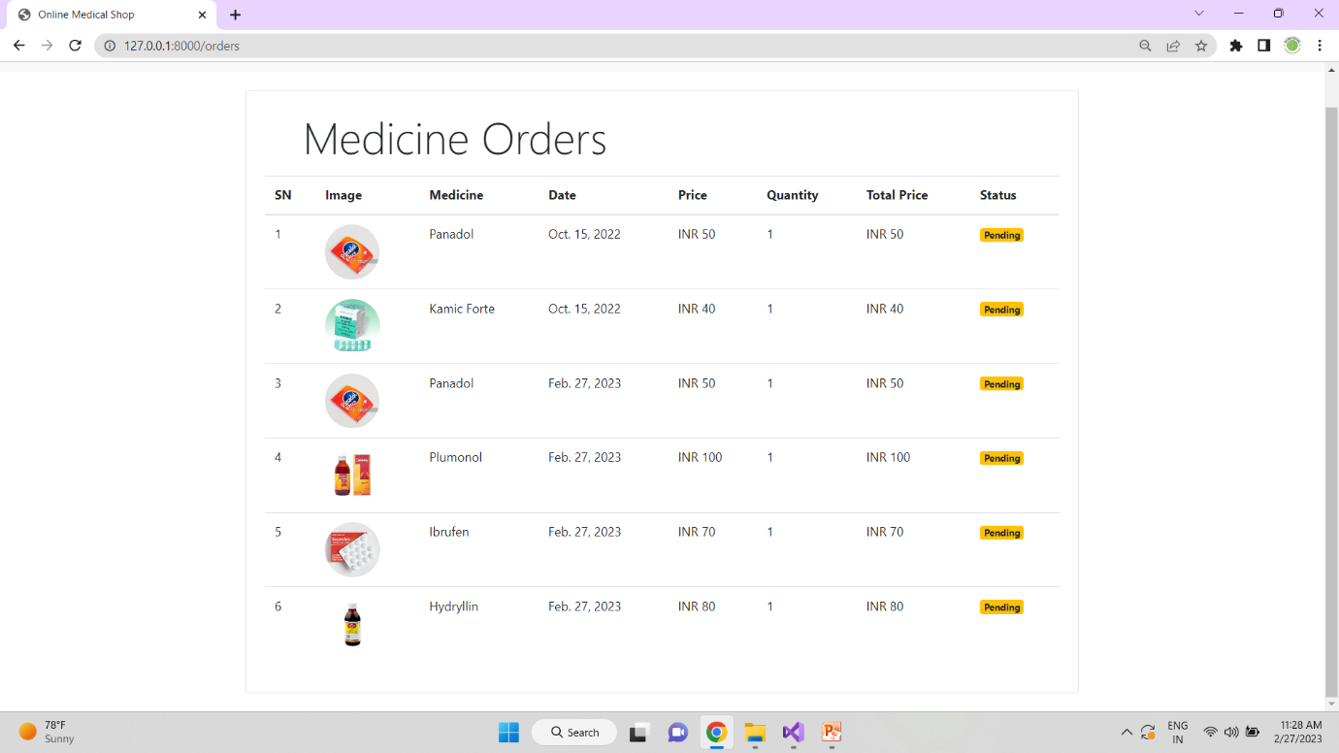

Figure 6.8: Pending Medicine Orders List

The list should include the name of the medicine, the dose, and the number of times a day you have to take it. Include information about how to take the medicine. Include information about any allergies.

**CONCLUSIONS**

This study was conducted to develop and implement a Medical Store Management System. The result of the study showed that the developed system met the needs and requirements of the intended users and respondents. The study showed that the respondents rated the system satisfactorily in terms of user acceptability, effectiveness, quality, reliability, and productivity. The majority of the respondents have seen the potential of the system in equipping medical stores with tools that will assist them to better manage the stores and provide better services to the customers.

The main goal of the project is to develop and implement a Medical Store Management System to digitally transform the operations and transactions of a medical store. The researchers specifically aim the following objectives. To eliminate the manual methods and paper works involved in managing a medical store. To automate medical store’s data recording and storing. To allow medical stores to electronically conduct stocks inventory to monitor stock supplies in the store. To ease up report generation about the store’s stocks, medicine information, customer billing, recording of purchases, and sales of the store. To assess the system in terms of user acceptability, effectiveness, quality, reliability, and productivity.

**REFERENCES**

* Herbert Scheldt, Java Complete Reference, Fifth Edition, Tata McGraw Hill Edition.
* Phil Hanna, JSP 2.0: The Complete Reference, Tata McGraw Hill Edition, 2003.
* Elmar and Navathe, Fundamentals of Database System (Third Edition), Addison Wesley.
* Ian Somerville, Software Engineering, Third Edition, Pearson Education.
* Ali Bahrami, Object-Oriented System Development, Third Edition, Tata McGraw Hill Edition.
* Ivan Bayross, SQL, PL/SQL programming language of Oracle, Second Edition, BPB Publication.